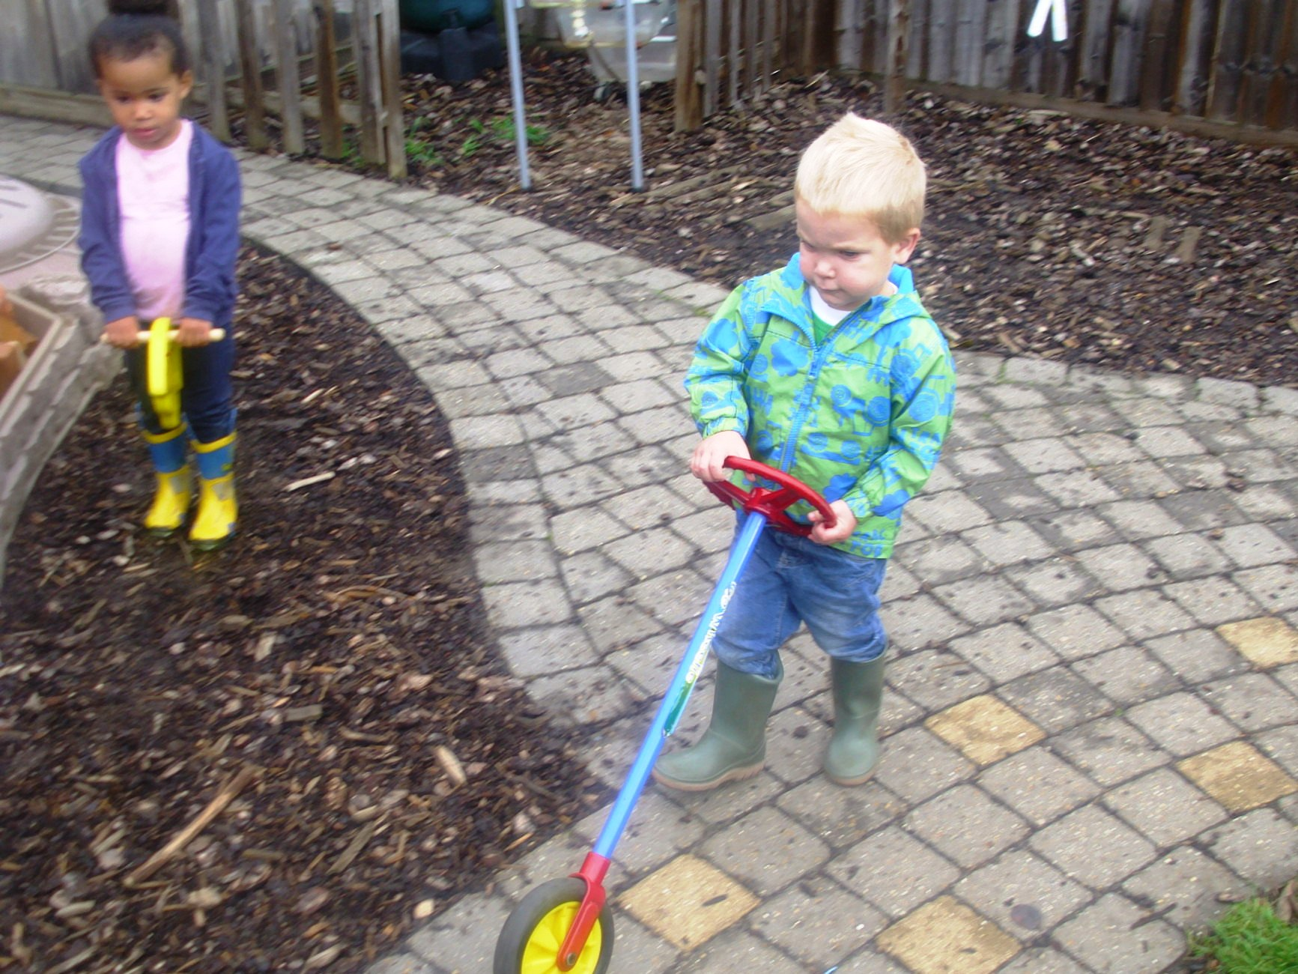
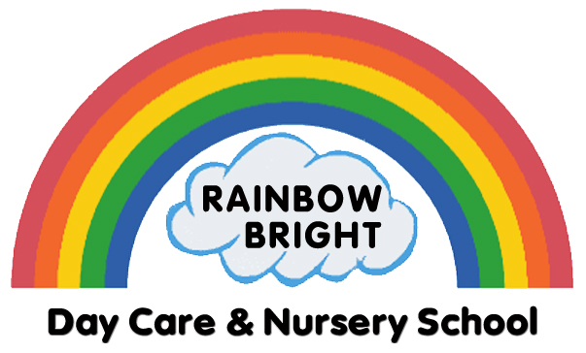
RAINBOW BRIGHT
NURSERY NEWS

NEWS
OUR WEBSITE &
FACEBOOK PAGE

We are so pleased with our new and improved website: www.rainbowbright.co.uk
We update it on a regular basis with useful information and photos under the blog tab.

We also post pictures on our Facebook page: www.facebook.com/RainbowBrightNursery
If you have not already, like us on Facebook and you may see a photo of your child in your newsfeed. Feel free to share!

Please note that all photographs are published with the permission of parents.


AUTUMN TERM 2013
KIMMY’S PETTING ZOO
Tying in with our Animal Theme, Kimmy stopped by and introduced us to some of her friends. Among our favourites were Stanley, the chinchilla, and Fifi, the skunk. We had lots of fun learning about them and playing with them. If you have given us permission to use images of your child, you may find some on our Facebook page (Rainbow Bright Day Nursery). If you have not given us permission, but are happy to do so, please alert a member of staff and we will send a form home with your child.
REFER A FRIEND!
Rainbow Bright is a small nursery with a family-like atmosphere and we love getting referrals from friends and family. We are offering a special promotion whereby if you refer a friend who starts attending, we will knock £50 off your fees! Spread the word and refer a friend today ☺

2 YEAR OLD FUNDING
Starting this Autumn Term, early years funding extends from 10 hours to 15 hours per week for eligible 2 year olds.
Eligible families will be in receipt of one of the following:

- Income Support
- Income-based Jobseeker’s Allowance
- Income-related Employment Support Allowance
- The Guarantee Element of State Pension Credit
- Child Tax Credit but not entitled to Working Tax Credit and annual income less than £16,190

For further information, please contact Tracy
EMAIL: tracymason.rainbowbright.co.uk
MOBILE: 079000 81709

Feel free to email

LETTER OF THE WEEK
GREEN AND RED GROUPS:
Please remember to bring in items that begin with the letter of the week:

W/c 4-11-13 Letter Ii
W/c 11-11-13 Letter Jj
W/c 18-11-13 Letter Kk
W/c 25-11-13 Letter Ll
W/c 2-12-13 Letter Mm

AUTUMN TERM THEMES
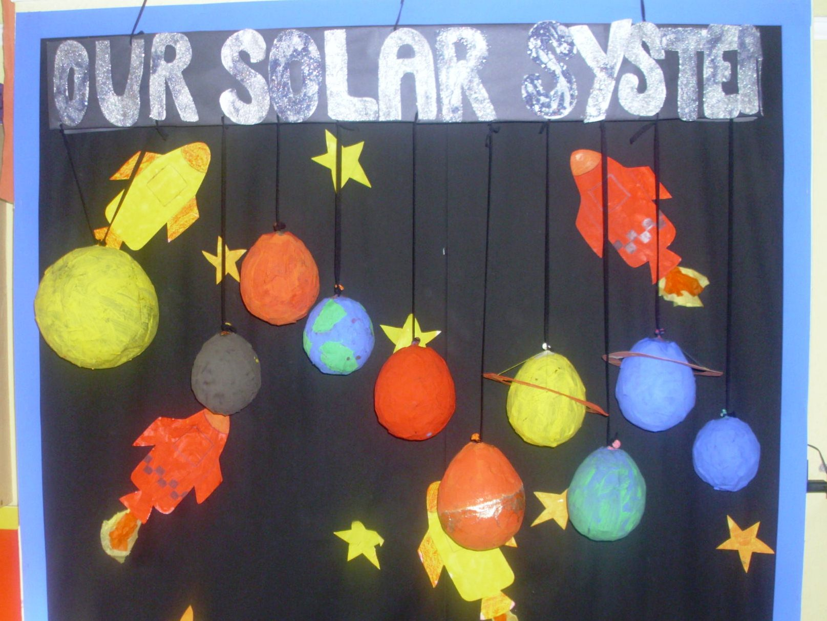
We explored the wonderful world of science for the first half of this Autumn Term. We made comets, flying saucers, papier mâché planets and learned all about magnets, water and wind power.

For the second half of the term, we will learn about autumn and winter celebrations.

PLEASE DO REMEMBER TO INFORM US OF ANY CHANGES TO YOUR PHONE NUMBERS AND ALSO PROVIDE AN EMAIL ADDRESS FOR RAINBOW NEWS
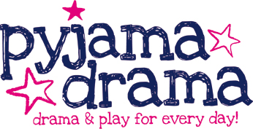

Imaginative play is great for children. We are happy to have Jane, from Pyjama Drama, come in for regular workshops. The next one will be the 7th November when a Teeny Tiny Hedgehog comes to visit.

PLEASE DO REMEMBER TO INFORM US OF ANY CHANGES TO YOUR PHONE NUMBER/ADDRESS. ALSO PROVIDE AN EMAIL ADDRESS FOR RAINBOW NEWS

FRIENDLY REMINDERS
Learning Journeys
We send out Learning Journeys twice yearly; however, you can view your child’s LJ anytime you like. Just ask a member of staff.
Sniffles and Sneezes
As winter approaches so do the coughs, sneezes, sniffles and those nasty viruses. In an attempt to keep everyone happy and healthy, we ask that you follow the 48 hour rule if your child has had sickness and/or diarrhoea. Guidance on infection control can be found in either hallway and online at: www.hpa.org.uk/HPAwebHome or you can always speak to a member of staff if you have any queries.

Coats and Wellies
Please bring in new coats and wellies (labelled with your child’s name) for lots of leaf crunching and mud pie making this autumn!

Welcome – We are very pleased to welcome all the newcomers who have joined Rainbow Bright since our last newsletter: Jack Reeveley, Jasmine Watson, Isla Hardwicke, Kyle Rogers, Riley Nichols and Tyler Rutherford.
We hope you will all have lots of happy nursery days with us.

EASTON FARM PARK TRIP
This year the green & red groups are going to take the Nativity outside nursery and join the animals at Easton Farm Park on Monday 16th December.
Each child will meet Santa and receive a present, as well as participate in a lovely Animal Nativity.

The NURSERY MOBILE 07824 191918
is the best way to communicate with staff. Please text/call to inform us of any illness or other daily information.

PLEASE DO REMEMBER TO INFORM US OF ANY CHANGES TO YOUR PHONE NUMBERS AND ALSO PROVIDE AN EMAIL ADDRESS FOR RAINBOW NEWS

